Upcoming Changes to Order Entry Packing list

This document is to make users aware of the upcoming changes to the packing list page in Order Entry. These changes were necessary to implement upcoming features to the page as well as to maintain consistency with the current layout of other Connect applications.

The new page will appear as follows:

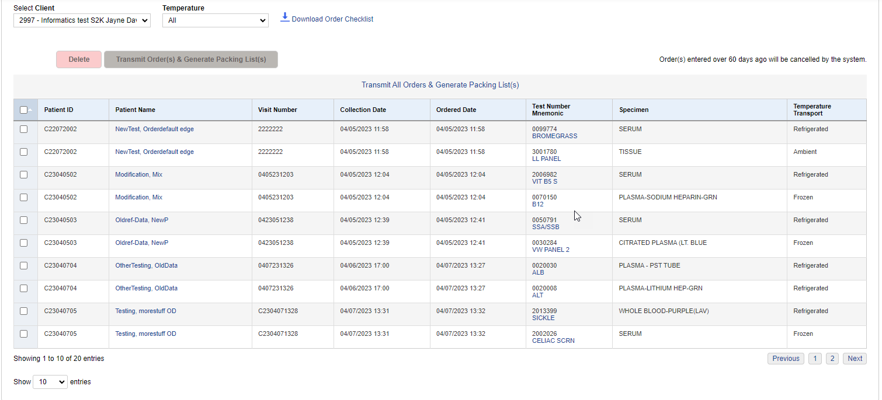

As you can see the screen looks different than before, but all the same functionalities can still be performed. The check boxes on the left of the page will work with the buttons above the grid.
These buttons will be inactive until a row, or rows, is selected.

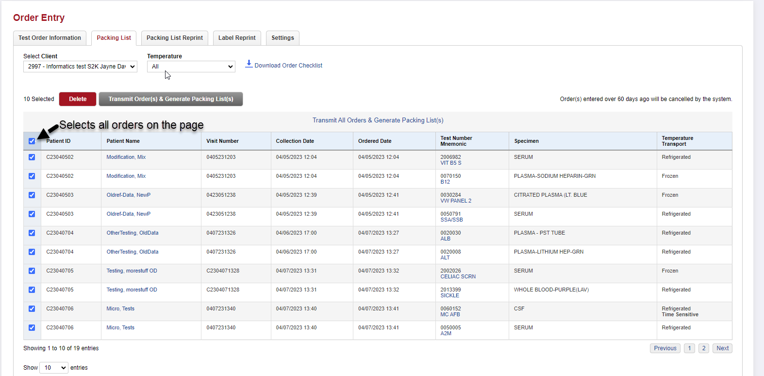

The check box at the top of the check box column will only select the visible items on that page. It will not select any items from additional pages.

You may change the number of rows visible on the page by changing this dropdown box.

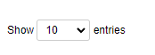

You may select from 5, 10, 20, or 50 rows per page. The system will let you know what rows you are viewing with an indicator at the bottom of the grid.

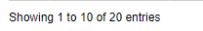

You can still use the filter at the top of the page to filter the grid to a specific temperature.
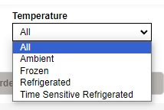
Looking at the image below, you can see we filtered the list to only show refrigerated tests.

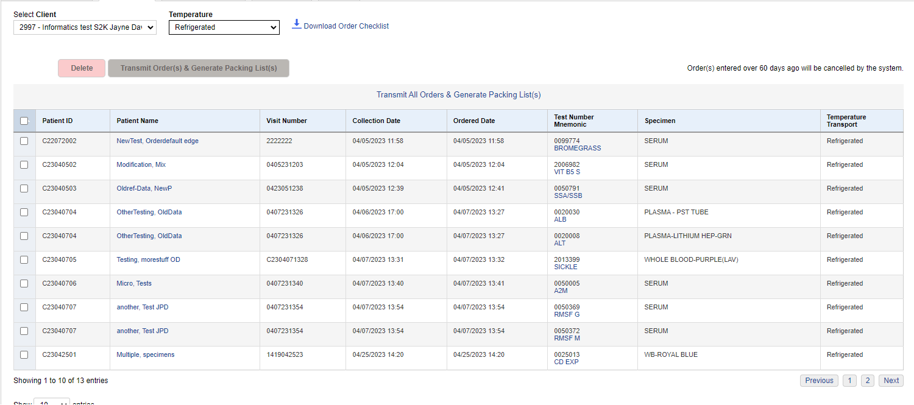

The Pre-Transmittal Worksheet has been renamed to Order Checklist and can be printed using the following link next to client selector.

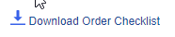
When deleting orders from the packing list screen you will select the row, or rows (not previously available), to be deleted and click the delete button. The system will ask for verification of the delete and will show the number of rows that will be deleted.

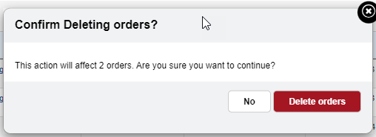

You can use the check boxes and the button to transmit only selected orders.

To transmit all orders from all pages, select the following link.
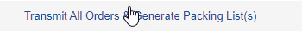

This will verify that you want to send all orders and indicate the number of orders that will be sent.
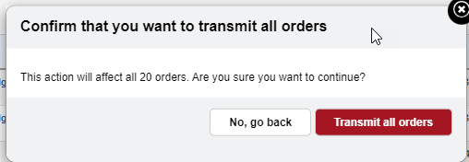

Clicking on the patient’s name in any row will bring you to the order page for that patient to edit or verify data as needed.

